Final Team Member Evaluations

Overview

Having completed your semester project, this is a retrospective evaluation of your team’s dynamics. Each team member, including yourself, is to be rated on two scales. The first is how much effort everyone put in. The second is how cooperative people were. Lastly, as your team has been “granted” $100,000 for your complete project efforts, the compensation breakdown should be proportional to contribution. These responses are confidential. Bring your completed evaluation, folded in half, to the Post Mortem on December 20.

Details

Team member’s name  (include your own) | Percent of effort for each person  (must add up to 100% for the team) | To what degree was he/she a good team member? (e.g., being helpful, cooperative, timely, agreeing to divide up the work equally) | Distribution of Proposal Funds  (how much should each analyst receive?)
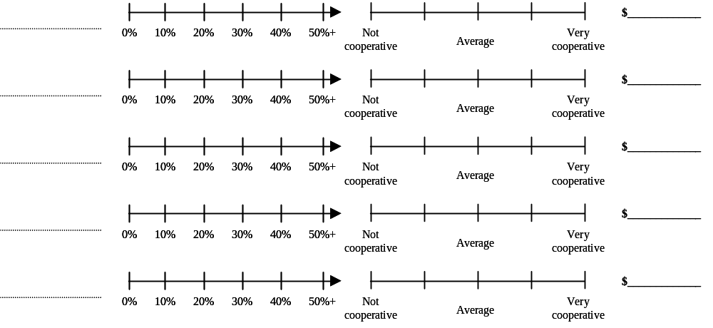
$100,000

Other comments:

